

**Soft Skills**

**Submitted By:**

**Shaikh Sameer**

**Lecture By: Ms Richa Maheshwari, Tutorials Point India Private Limited**

**What Are Soft Skills?**

Soft skills refer to a cluster of Personal Qualities, Habits, attitude and Social Graces that make someone a Good Employee and compatible to work with.

Soft skills are what you need to get a job and help you to be a good employee. Some

of the most common soft skills that employers are looking for include:

• **Having a positive attitude**

**• Being able to communicate (talk) with Others; this also includes being a good Listener**

**• Getting along with others**

**• Being able to manage your time**

**• Being able to solve problems**

**• Being respectful toward others**

**• Being a team player**

**• Being confident**

**• Having good grooming and hygiene**

**Why Do I Need Soft Skills?**

Employers want employees who are able to work well with others. Employers feel that having good soft skills are just as important as having the skills to do the job.

**Communication**

Communication skills are important to everyone - they are how we give and receive information and convey our ideas and opinions with those around us. Communication comes in many forms:

• **verbal** (sounds, language, and tone of voice)

• **aural** (listening and hearing)

• **non-verbal** (facial expressions, body language, and posture)

• **written** (journals, emails, blogs, and text messages)

• **visual** (signs, symbols, and pictures)

**Communication skills are ranked FIRST among a job candidate’s “must have” skills and qualities, according to a 2010 survey conducted by the National Association of Colleges and Employers.**

It is important to develop a variety of skills for both communicating TO others and learning how to interpret the information received FROM others. Knowing our audience and understanding how they need to receive information is equally important as knowing ourselves. To an employer, good communication skills are essential. In fact, employers consistently rank good communication skills at the top of the list for potential employees. During an interview, for example, employers are impressed by a job candidate who answers questions with more than one-word answers (such as yeah…nah…dunno), demonstrates that he or she is listening, and shares information and ideas (by asking questions for clarification and/or follow-up). The interview can be an indication to employers of how the candidate or employee will interact with supervisors, co-workers, and customers or resolve conflicts when they arise. Remember, non-verbal communication is also critical in an interview. Employers expect good eye contact, good posture, and “active” listening.

One of the challenges in the workplace is learning the specific communication styles of others and how and when to share your ideas or concerns. Though some supervisors may specifically ask for your opinion, others may assume if there is something important they need to know, you will bring it to their attention – or if there is something you are unsure about, you will ask. Knowing how to listen carefully and when to ask for help is important. If an employee and a supervisor learn to communicate well (in whatever method that works), there is a greater likelihood of job retention and promotion.

**Course: Soft Skills Overview**

**What happens when you don’t possess Soft Skills?**

* **Lack of Satisfaction**
* **Less or no respect in the Society**
* **Poor influence in group**
* **Lack of appreciation and recognition**
* **Criticism in all levels of Life**

**Personal attributes which people look For**

1. **Honesty**
2. **Interpersonal Skills**
3. **Integrity**
4. **Dedication**
5. **Manners & Etiquettes**
6. **Ethics**
7. **Persistence**
8. **Pride in Work**
9. **Good Listener and more…**

**Benefits of Soft Skills to Organisation**

* **Increased Credibility with Customers**
* **Increased Customer Satisfaction**
* **More Productive Employees**
* **Out- Service the competition**
* **Increased Employee (ROI)**
* **Strong Team and Leadership**
* **Demonstrated dedication to Customer Service and Support**
* **Measurable results and Improvements**
* **Incentives, Rewards and Challenges for employees**

**Benefits of Soft Skills to Individuals**

* **Recognition from the industry, Employer and peers**
* **New Employment Opportunities**
* **Promotions and Advanced Opportunities**
* **Increased ability to perform on the Job**
* **Increased responsibility**
* **Lifelong Credentials**
* **Professional Accomplishment**
* **Businessmen**
* **Public Sector Executives**

**Course: Soft Skills in Developing Personal Effectiveness**

**Personal Effectiveness**

Personal Effectiveness means making the most of all your personal resources at our disposal- Our personal talent, energy and time related to what is important to us

**Habits**

**We are what we repeatedly do. Excellence, then, is not an act, but a habit**

**--Aristotle**

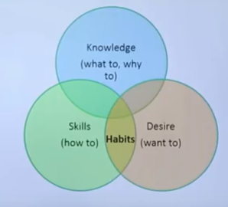

**How Habits are formed**

* Formed overtime without our conscious intent
* Ultimately they become ingrained
* Brain link specific behaviour with rewards
* More immediate the rewards, the stronger the link
* Repeating the reward will reinforce the habit

**Paradigms**

**What is a Paradigm?**

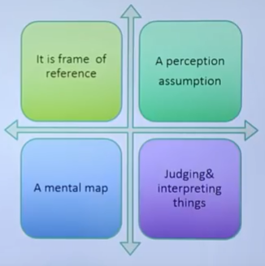

**7 Habits of Highly Effective People**

* Habit 1 - Be proactive
* Habit 1 - Begin with the end in the mind
* Habit 1 - Put first things first
* Habit 1 – Think WIN-WIN
* Habit 1 – Seek first to understand and then to be understood
* Habit 1 – Synergize
* Habit 1 – Sharpen the Saw

**7 Habits move through these stages**

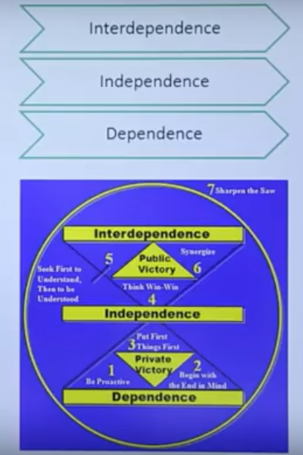

**Habit 1 - Be Proactive**

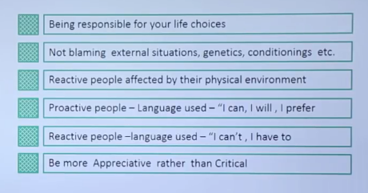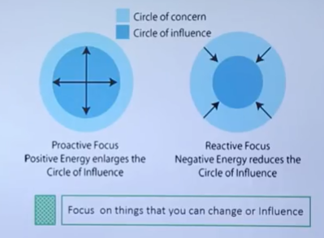

**Habit 2 – Begins with Mind in Mind**

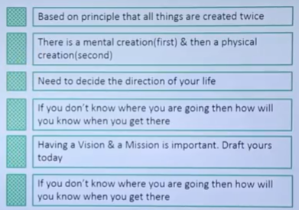

**Habit 3 – Put First Things First**

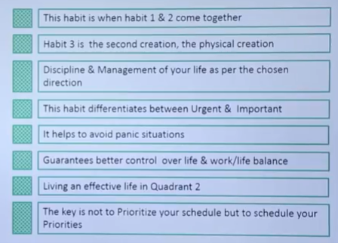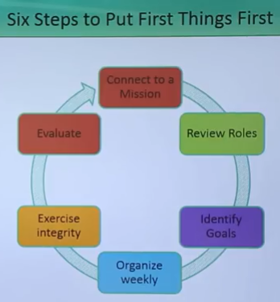

**Habit 4 – Think and WIN**

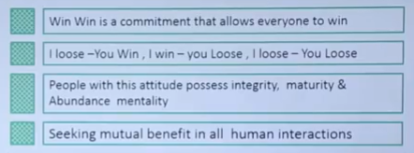

**Habit 5 – Seek first to Understand then to understood**

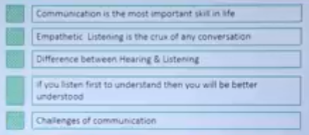

**Habit 6 – Synergize**

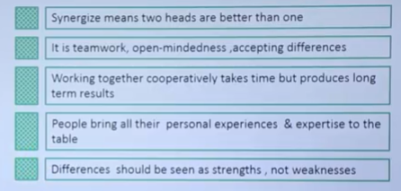

**Habit 7 – Sharpen the SAW**

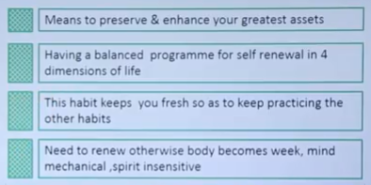

**4 Dimensions for self Renewal**

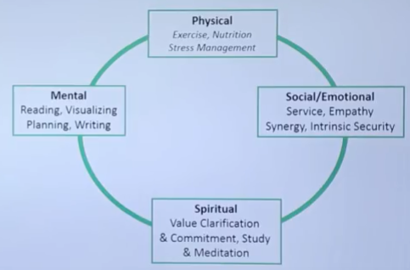

**Successful Habits**

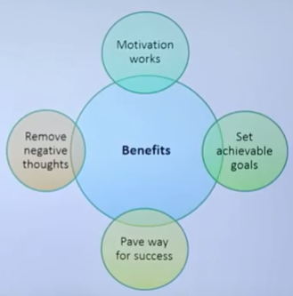

**Soft Skills : Decision Making**

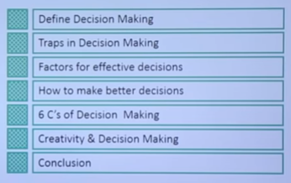

**Personal Traps in Decision Making**

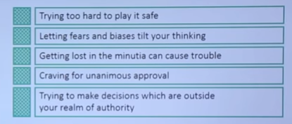

**Making Effective Decisions**

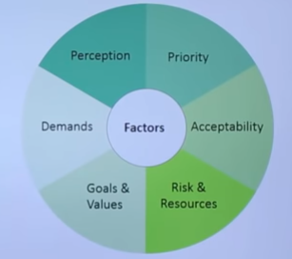

**How to make decisions better**

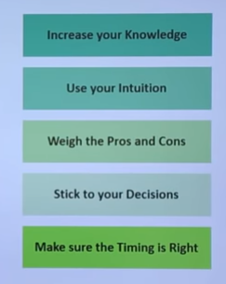

**Common mistakes while making Decisions**

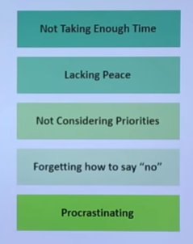

**6 C’s of Decision making**

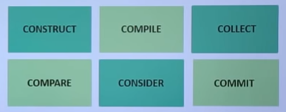

**Soft Skills: Presentation Skills**

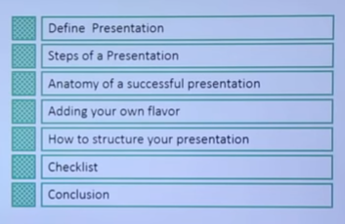

**Step 1: Formulating a Strategy**

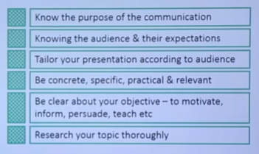

**Presentation Style**

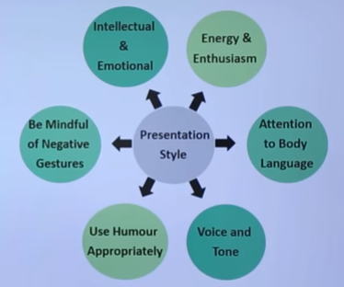

**Handling Questions and Challenges**

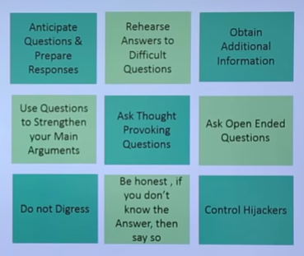

**Checklist for effective Presentation**

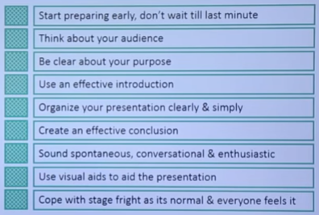

**Soft Skills – Problem Solving**

**Agenda**

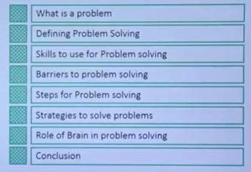

**What is a Problem?**

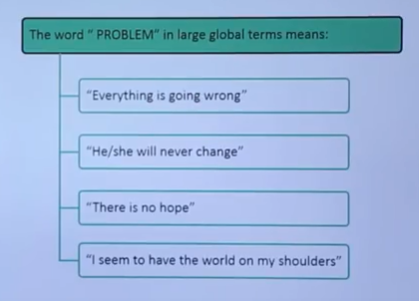

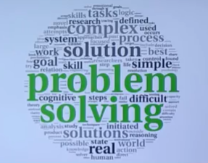

A Systematic Approach to defining a the problem (questions or situations that presents uncertainty or difficulty) and creating a vast number of possible without judging these solutions

**What is Problem Solving?**

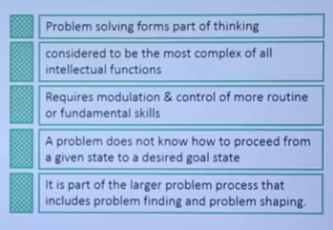

**Skills to use Problem Solving**

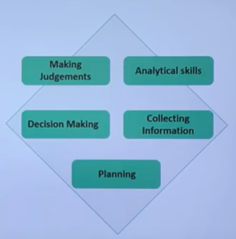

**Barriers to Problem Solving**

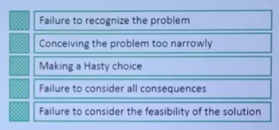

**Accepting the problem**

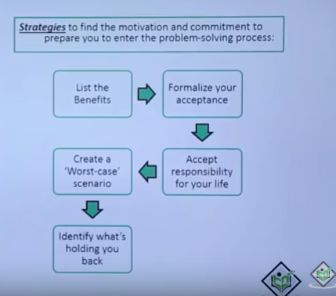

**Steps for Problem Solving**

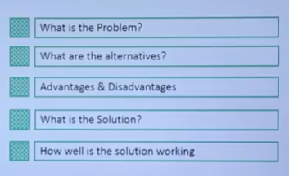

**What is the Problem?**

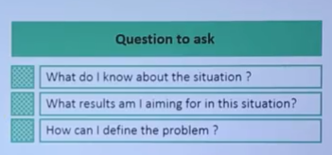

**Define the Problem**

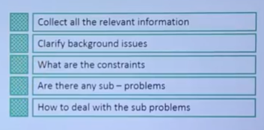

**Ask Questions analysing the problem**

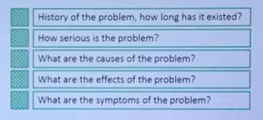

**Alternatives**

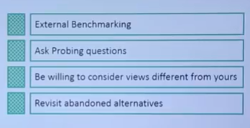

**What is a Solution?**

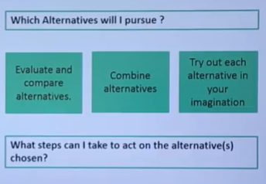

**How well is Solution working**

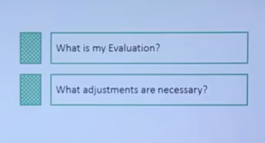

**Decoding Left & Right Brain**

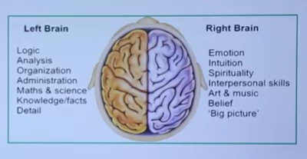

**References**

1. [**https://www.youtube.com/watch?v=Ih3zVyz8H8U**](https://www.youtube.com/watch?v=Ih3zVyz8H8U) **: First Time Managers**
2. [**https://www.youtube.com/watch?v=MURgliJjbH4**](https://www.youtube.com/watch?v=MURgliJjbH4) **: Developing Personal Effectiveness**
3. [**https://www.youtube.com/watch?v=DwwBZn5duk8**](https://www.youtube.com/watch?v=DwwBZn5duk8) **: Leadership Vs Management**
4. [**https://www.youtube.com/watch?v=giYCzByXCok**](https://www.youtube.com/watch?v=giYCzByXCok) **: Training Course**
5. [**https://www.youtube.com/watch?v=nJmteC2wfRo**](https://www.youtube.com/watch?v=nJmteC2wfRo) **: Decision Making**
6. [**https://www.youtube.com/watch?v=x60GHpQ8gJk**](https://www.youtube.com/watch?v=x60GHpQ8gJk) **: Overview**
7. [**https://www.youtube.com/watch?v=uqhOnXOiwOg**](https://www.youtube.com/watch?v=uqhOnXOiwOg) **: Problem Solving**
8. [**https://www.youtube.com/watch?v=2bf9K2rRWwo**](https://www.youtube.com/watch?v=2bf9K2rRWwo) **: Introduction and Greetings**
9. [**https://www.youtube.com/watch?v=ADJAcyTq1us**](https://www.youtube.com/watch?v=ADJAcyTq1us) **: Presentation Skills**